
hydroscule bridge
poster

April 12, 2024

Team 10129

Abstract:
The problem to be solved is urban congestion, a problem that faced Egypt throughout its modern history, which is the reason behind other issues like connectivity. The chosen solution to the stated problem is constructing a bascule bridge to connect two areas of high population density to improve connectivity and reduce urban congestion. Egypt faces multiple grand challenges, two of which are Urban Congestion and Population Growth, Population Growth is caused by bad population growth as Egypt’s area is 1002000 KM^2, however only 105199 KM^2 is inhabited, which causes pollution as Population growth increases pollution. Egypt is ranked 9th in air pollution. Egypt holds the 12th position in the global pollution index, with a score of 82.7 making it one of the most polluted countries in the world, furthermore most of the population is around the Nile banks leaving urban congestion in all populated cities. Urban Congestion is caused by an increased birth rate as Egypt has a fertility rate of 3.097 births per woman, one of its impacts is the deterioration of public health as Egypt has one of the largest populations in the Middle East. High fertility in many parts of Egypt causes overpopulation leading to urban congestion. The current fertility rate for Egypt in 2024 is 3.097 births per woman, a 1.09% decline from 2023. To construct a successful prototype, the design requirements will be the following, the bridge must be at least 1 meter in length, 22cm in width, and must be able to carry 10kg with a maximum deflection of 5cm.
Introduction:
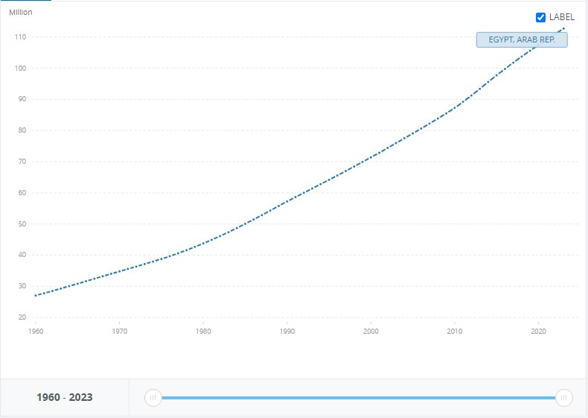
Population growth is a threatening problem that faces Egypt which has a population of 106,890,565. As illustrated in Figure (1), the population in Egypt went from 27M to 112M in 63 years with a 314% increase in population and 2% growth a year, the Greater Cairo Metropolitan Area (GCMA) which has fifth of Egypt’s population is expected to further increase to 24 million by 2027, with Birth numbers exceeding deaths which makes Egypt more and more crowded than ever in each minute passing, as a direct result, more people are using up the same resources, space, and public sectors. So, population growth in this area can cause urban congestion which leads to severe problems, most severe of which is connectivity, the problem to be solved.
Fig. 1 Rate of Egypt's population growth
After research, a multitude of solutions already tried were found, two of which are Tower Bridge and Hawthorne Bridge. Tower Bridge is an important bascule bridge in London, one of its strengths is its transportation importance as it can carry 40,000 people and 21,000 vehicles. The bridge's bascules are lifted around 800-1,000 times per year to allow the passage of tall ships and river vessels. While on the other hand one of its weaknesses is sensitivity to vibrations as when the bridge bascules open, they're subject to vibrations and oscillations. Over time, this can cause wear and tear, necessitating frequent maintenance. The other solution already tried is Hawthorne Bridge, one of the busiest bridges in Portland is a vertical lift bridge in Portland, USA. One of its strengths is its transportation importance as it serves as a route between downtown Portland and the South Waterfront. One of its downsides is limited vertical clearance due to its vertical lift mechanism.

The dimensions of the prototype are as follows: the scale is 1:50. The total length of the bridge is 100cm. The bridge has two lanes of traffic, and the width of the traffic lane is 7 cm. It also has two lanes for pedestrians with a width of 3cm. An island of 2cm exists in the middle width of the bridge. The clearance between the water level and the lowest point of the deck of the bridge is 10 cm. The bridge should allow the passage of ships that need a minimum width of 24cm, a maximum width of 28cm and a minimum height of 20cm. The bridge should be able to carry a traffic load of a minimum 10 kg mass at the midpoint of the bridge of the largest fixed span. The maximum deflection at the same point doesn’t exceed 5 cm without collapse. The maximum weight of the prototype shouldn’t be more than 20 kg. By these dimensions, the bridge will meet the design requirements.

Materials and methods:

Table (1): Materials
Material | Description | Quantity | Picture
Palm midrib | It is used as a material for making trusses, decks, and pillars. | 36 rods | 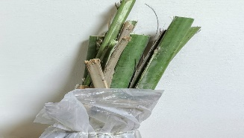
Adhesive glue(mdf) | It is used as a sticky material | 4 bottles | 
Steel wires | Connecting between the midrib rods in the truss and the deck. | 1 | 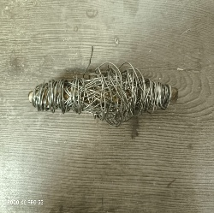
Syringes | It is used as a hydraulic lifter | 8 | 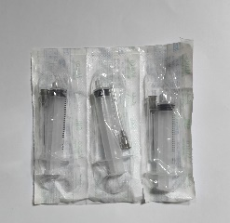
Glue gun | It is used to stick | 1 | 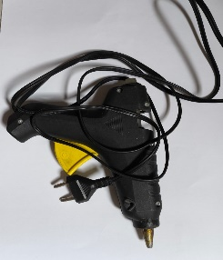
Hose | It is used to transfer water from one syringe to the other syringe | 8 | 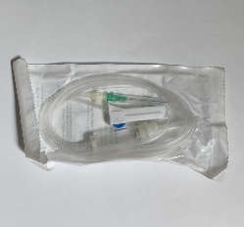
Measuring tape  Nails | It is used to measure the length of every component in the bridge  It’s used to connect the deck with the truss and the rest components with each other. | 1  2 boxes |   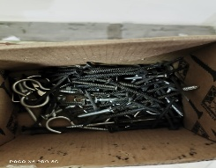

Methods:
- For the sake of constructing a successful prototype, a 3D design was done first to visualize the prototype's shape.

- Nearly perfect cuboids were cut of the palm midribs to be used as the main part of construction.

- The bridge was divided into three spans: two fixed spans and a movable one consisting of 2 moving leaves.

- A warren truss with verticals was constructed, the members are from palm midrib.

- The palm midrib was cut into members and attached with adhesive glue and nails.

- The base of the deck was constructed 1 meter in length and then cut round cylinders to the role of the piers and stuck to the deck.

- Two other piers were made, and two syringes were put in them to act as the 2 hydraulic lifters.

- A hole was made in the two piers to put a hose in the two syringes to pump water into them.

- The hose was connected to another syringe outside of the bridge used to pump water into the one that’s inside.

Test plan:
A test plan should be performed to determine the prototype's efficiency and whether it works or not.
•The test plan for this prototype was to put a kilo by kilo to 5 kg to see if the bridge could bear this weight and it bear the weight successfully.
•After that, 60 kilos were placed on the fixed span, which didn’t break.
•Then, the measurements of the bridge were revised so that they all were correct and accurate and matched the design requirements. To get accurate results, measurements should be measured by millimeters and look horizontally at the measuring tape.
•To test the deflection in the bridge, the used machine is motion sensor which has given accurate results with a maximum deflection of 1.25cm.

Results:
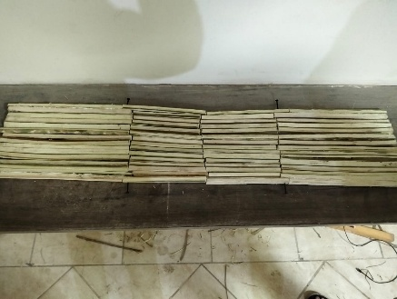
Negative results:
Figure 2. deck with error.
- When the deck was constructed and measured, the results stated that the widths of the two ends of the deck weren’t equal as shown in Figure (2), so it was reconstructed using straighter parts and a right triangle to check the angles.

- When the movable part was glued, it wasn’t strong enough and broke, so we used nails to ensure its strength as shown in Figure (3).
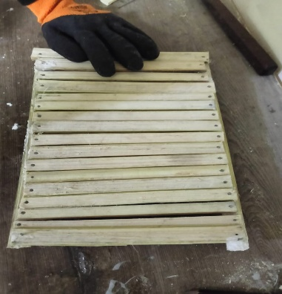
Figure 3. accurate deck.

- When the mechanism was tested, the syringe lifted the movable part but alongside the fixed part because the fulcrum wasn’t light enough, so a lighter fulcrum was used to fix the problem.

Positive results:
- After constructing the deck, the load was put on the deck and continuously increased to test the deflection, and the results were as shown in Fig (4) and in Table (3).

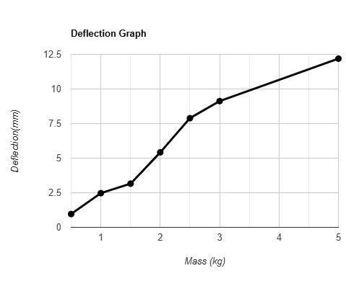
- After opening the bridge, an empty area of 12*10 M^2 was provided to allow ships access.

- The prototype was put on a scale for weight test, and the results were 9 KG.

Table 2: the errors in the lengths of the bridge
Figure 4 deflection graph
Object | Length | Width | Height | Unit
Diagonal truss member | 13±0.05 | 0.5±0.05 | 0.5±0.05 | CM
Vertical truss member | 11.5±0.05 | 0.5±0.05 | 0.5±0.05 | CM
Fixed part of the deck | 30±0.05 | 22±0.05 | 4±0.05 | CM
The movable part of the deck | 20±0.05 | 22±0.05 | 2±0.05 | CM
beam | 0.5±0.05 | 0.5±0.05 | 10±0.05 | CM
Deflection(mm) | Load(Kg)
0.9604 | 0.5
2.4696 | 1
3.1556 | 1.5
5.4194 | 2
7.8890 | 2.5
9.1238 | 3
12.1922 | 5

Analysis:
Force analysis:
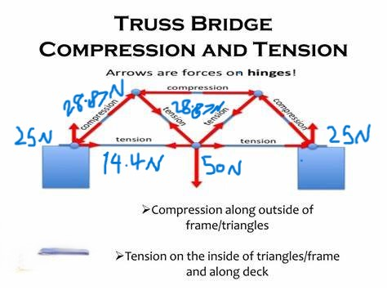
When conducting a truss analysis for the bridge, it is important to know the forces acting on the truss members under the given load, which is 5 kg. The release of the truss system from external supports and the equilibrium conditions for whole truss external reactions were computed and from equilibrium conditions for released joints unknown axial forces were computed in members. By starting with the joint in which external forces (or reactions) are known and where there is a maximum of two unknown axial forces. The members in which there are zero forces are called zero members. Even if those forces are not loaded, they are necessary for ensuring the stability of the truss. By using the method of joints to distribute the forces the following results have appeared that the compression members can lift a force of 28.87 newtons and the tension member can lift 14.4 newtons as shown in figure (5).
Figure 5 force analysis
$$\sum{ fx=zero, \sum{fy=zero} }\sum{M=zero}$$

Young’s modulus:
Young’s modulus is a fundamental mechanical property that is used to measure the stiffness of a material. Young’s modulus is defined as the stress of the material (force per unit area) to the strain of the material (Length/ change in the length). The palm midrib, which is the central structure support of the palm trees, has gained attention due to its unique properties like stiffness and durability. It helps you to choose the best material for the prototype model. In this prototype, the used material is the palm tree. The results show that the eight parts of date palm wood consist mainly of cellulose, hemicellulose, and lignin with an average of 40, 20, and 28 wt%, respectively. They are characterized by low value of density which is generally less than 600 kg/m 3 and low rate of water absorption (under 100% except for Petiole, Spathe, and Fibrillium). Date palm wood ranges among the materials that have weak mechanical properties (the tensile strength ranged from 86 to 213 MPa, Young’s modulus ranged from 3 to 8.5 GPa, and elongation at break close to 3%); however, it is characterized by high specific properties which constitute one of the principal advantages of using it to develop lightweight and high strength materials.
$$E=\frac{stress}{strain}=\frac{F/A}{∆L/Lo}$$

Deflection:
The deflection of a beam refers to the amount it bends under a given load. It can be calculated using many formulas and methods depending on the load, boundary conditions, and the beam's material properties. There is a general formula for the deflection which can be determined through the elastic curve equation from Euler-Bernoulli beam theory: $\frac{d^{2}y}{dx^{2}}$=$\frac{M(X)}{EI}$ Where:
- y: Vertical deflection of the beam
- x: Horizontal position along the beam
- M(x): Bending moment as a function of x
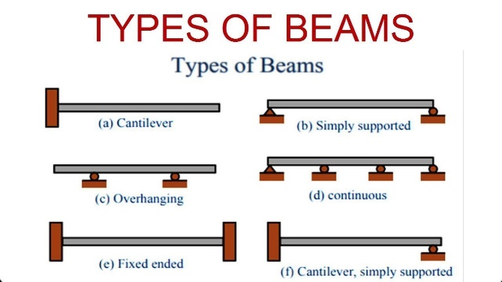
- E: Young's modulus (material stiffness)
- I: Moment of inertia of the cross-sectional area about the neutral axis
There are some laws for calculating the deflection of the bridge depending on the type of beam as shown in Figure (6). The common cases for deflection are the simply supported beam with a point central load and the cantilever beam with an endpoint load. The beam in this bridge is simply a supported beam. Load at the center, L: Length of the beam. After calculating the results, the maximum deflection was 1.25CM.
Figure 6: types of beams

Pascal law:
The law states that a change in pressure at any point in an enclosed fluid at rest is transmitted undiminished to all points in the fluid, which is represented in the formula F1/A1 = F2/A2.

$P=\frac{F1}{A1}=\frac{F2}{A2}$

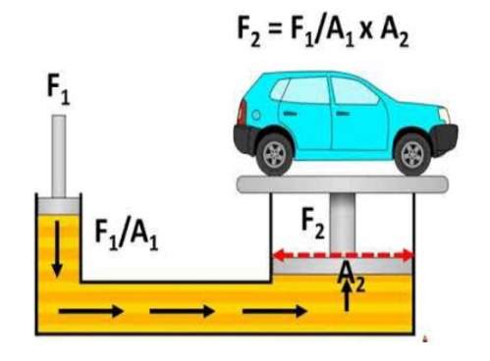
(A1) is the area of the surface that applies the pressure to the fluid. (F1) is the force exerted by the surface that applies the pressure to the fluid. (A2) is the area of the surface that is pushed by the force of the fluid. (F2) is the force exerted by the fluid at the other side of the tube. The Pascal law is used to double the force in a particular mechanism with less energy. It’s very helpful as you may lift or hold very heavy objects with mere force as shown in fig (7). For instance, if you enclose fluid in a tube that’s 1cm^2 on one side and 50cm^2 on the other side. when a 100N force is exerted on the small side, the other side can hold a force equal to 5000N. in the prototype, it’s used to apply the force needed to lift the bridge by transmitting a small force through it. This principle was applied in the project to calculate the force needed to lift the movable part of the deck, and the result was 12.5 N.
Figure7. hydraulic system
Learning outcome:
Table 2 lo connections
Chemistry lo1 | This lo illustrates the errors in measurements and accuracy used in the prototype to determine the error in the weight that it lifts. | Math lo2 | This lo explains the graphs and their types, so representing data from the test line equation could be easier. A scatter plot can be used to measure the deflection of the bridge while increasing the force acting on the bridge
Physics lo2 | This lo explains the forces and how to distribute them, in the prototype it is used to determine the forces applied to the members. | E.S lo3 | This lo analyzes and identifies the earth materials that are used as a resource for modern buildings and integrates design criteria and material properties in choosing materials for engineering design. So, it is very useful in choosing the materials that suit the design requirements.
Physics lo6 | This lo explains Young’s modulus, which can be used to determine the stiffness of the material used in the bridge | Mechanics lo4 | This lo explains force as a vector; the force has magnitude and direction, so the force that is downwards is positive, then the force upward is negative with the same magnitude, so they cancel each other.

Conclusion:
The hydroscule bridge benefits Egypt and fixes many of its problems and grand challenges. Constructing this bridge connects a bunch of areas and cities. creating a better and more sustainable traffic network and reducing traffic jams and pollution in congested areas.
It also provides multiple means of transportation and better access through different environments. The bridge allows vehicles such as cars or trucks to pass on it, and boats under it. The bridge's ability to open vertically allows even larger boats and ferries to pass as it provides an area of 12M*10M after opening.
It also helps with pollution reduction and material recycling. Since traffic jams and urban congestion are vital reasons for air and water pollution, the hydroscule bridge is a great solution to such a challenge. And because our bridge is mainly constructed of recycled materials such as palm midribs it’s great to have it for the environment.

Recommendation:
Mechanical hydraulic:
While choosing the mechanism, it’s recommended to use a mechanical hydraulic system, instead of, a manual hydraulic. A mechanical hydraulic is made with a huge cylinder, gears, a motor, and a pumping pistol. The motor is connected to the gears, which are also connected to the pumping pistol, all inside the cylinder. Hydraulic fluid, which is a special material used in hydraulic systems, is contained in the cylinder between the pumping pistol and the slave pistol. When the motor is turned on, the gears rotate in the system making the pistol pump the hydraulic fluid pushing the slave pistol and lifting the deck. It is better than its manual equivalent because it will be able to hold the load of the traffic better, and because turning on the mechanism is easier as you don’t need the effort needed in a manual hydraulic. Moreover, research can be done using modern technology in the future.

Energy recovery system:
In the construction of the bridge, a technology inside the hydraulic system can be added. A technology that can take advantage of the kinetic energy produced by the fluid pumped in the cylinder, and recover the energy consumed by the motor, that can be best described as an Energy Recovery System. This system includes small water wheels built in. When the hydraulic fluid moves these water wheels are rotated, which produces energy that can be used in the motor by connecting it with the system. This system recovers the energy consumed by the motor and converts it to be used in the motor again, which is why it’s called an energy recovery system. This system wasn’t applied in the current project because the technology needed was out of reach.

Eco-friendly hydraulic fluid:
While constructing the mechanism, a specific fluid is used as the main part of the hydraulic. Hydraulic fluids are fluids made specifically for hydraulics. It’s recommended to use eco-friendly hydraulic fluids, like biodegradable hydraulic fluids. These fluids do not contain mineral lubricating oils; they are based on high-quality vegetable oil esters, which are more easily biodegraded, less hazardous, and more suitable for use in environmentally sensitive areas in comparison with mineral oil-based lubricants. Using these hydraulic fluids will reduce pollution as they are eco-friendly and don’t include any polluting elements. It wasn’t applied in this project for two reasons; it’s not available in Egypt, and its high cost was a preventive to use it.

Hydraulic fluid heating system:
When the cylinders are constructed, a hydraulic fluid heating system is essential. During the changes between seasons and the change in climate and temperature, the hydraulic fluid expands and condenses. To solve this problem a hydraulic fluid heating system is added to the mechanism, and it can be powered using the energy produced from the energy recovery system. It is programmed to keep the temperature of the hydraulic fluid constant, preventing the expansion in the fluid. It’s vital as the expansion of the hydraulic fluid is capable of destroying the whole project. This wasn’t possible due to the limitations of the materials and the complexity of installing the hydraulic fluid heating system as it’s dangerous to use because it can burn the palm midribs.

Literature citied:
Lengvarský, P., & Bocko, J. (2016). The static analysis of the Truss. American Journal of Mechanical Engineering, 4(7), 440–444. https://doi.org/10.12691/ajme-4-7-38.
Roark, R. J., Young, W. C., & Budynas, R. G. (2002). Roark’s Formulas for Stress and Strain. McGraw Hill Professional.
Almi, K., Benchabane, A., Lakel, S., & Kriker, A. (2015). Potential utilization of date palm wood as composite reinforcement. Journal of Reinforced Plastics and Composites, 34(15), 1231–1240. https://doi.org/10.1177/0731684415588356.

Pascal’s Principle and Hydraulics. (n.d.). https://www.grc.nasa.gov/www/k-12/WindTunnel/Activities/Pascals_principle.html.

Tkáč, Z., Čorňák, Š., Cviklovič, V., Kosiba, J., Glos, J., Jablonický, J., & Bernát, R. (2017). Research of biodegradable fluid impacts on operation of tractor hydraulic System. Acta Technologica Agriculturae, 20(2), 42–45. https://doi.org/10.1515/ata-2017-0008\.

Acknowledgment:
First of all many thanks to Allah for enabling us to successfully complete this project and fulfill all the design requirements, and secondly many thanks to our honored teachers, most notably, our English teacher for the assistance in academic writing, our math teacher for helping us in understanding the analysis, and our chemistry and geology teachers for their help in choosing the materials, and last and most important, many thanks to doctor Metwally Abu Hamad from the faculty of engineering in Cairo university for helping us understand the truss and guiding us for the best choices.

